Exercise 2: E-commerce Platform Search Function
What is Big O Notation?
- Big O notation is used to describe the efficiency of an algorithm.
- It tells how the time or space used by an algorithm increases as the input size increases.
- It helps compare algorithms without depending on hardware or specific input values.
- It mainly focuses on how fast or slow an algorithm performs in the worst-case scenario.
Common Notations:
- O(1) – The algorithm takes the same amount of time no matter the input size.
- O(n) – The time grows in proportion to the input size.
- O(log n) – The time grows slowly even as the input size increases.
- O(n log n) – The time grows faster than linear but slower than quadratic.
- O(n²) – The time grows quickly as the input size increases, especially with nested operations.
Best, Average, and Worst Cases in Search:
- Best Case – The condition where the algorithm finishes the fastest.
- Average Case – The expected performance over a range of typical inputs.
- Worst Case – The condition where the algorithm takes the longest time to complete.
- In linear search: Best case is very quick and average and worst cases take longer as input size increases.
- In binary search: All cases perform efficiently with increasing input size, especially if the data is sorted.
Output:
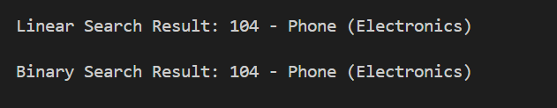
Time Complexity Comparison
- Linear search takes more time as the number of products increases.
- Binary search takes much less time because it reduces the search space quickly.
- Both use a small and fixed amount of extra memory.
Which is Better for E-commerce Search?
- Binary search is better for e-commerce platforms with large and sorted product lists because it is faster.
- Binary search is more efficient when the same search happens many times.

